2. 8 QUEEN PROBLEM
Aim
To solve the 8-Queen Puzzle using the Backtracking algorithm in Python.
Objective
- To place 8 queens on an 8 × 8 chessboard.
- To ensure that no two queens attack each other.
- To implement the Backtracking technique using Python.
Algorithm
- Start.
- Set N = 8 and create an empty 8 × 8 chessboard.
- Define a function safe(row, col) to check whether a queen can be placed at the given position:
  - Check the left side of the current row.
  - Check the upper-left diagonal.
  - Check the lower-left diagonal.
  - If no queen is found in these directions, return True; otherwise, return False.
- Define a function queen(col) to place queens column by column.
- If col = N, all 8 queens have been placed successfully. Return True.
- For each row in the current column:
  - Check whether the position is safe using safe(row, col).
  - If it is safe, place the queen.
  - Recursively call queen(col + 1) to place the next queen.
  - If the recursive call returns True, stop and return True.
  - Otherwise, remove the queen (backtracking) and try the next row.
- If no position is safe in the current column, return False.
- Call queen(0) to start placing queens from the first column.
- If a solution is found, display the chessboard.
- Stop.
This algorithm is 100% consistent with your Python code and is suitable for lab record submission.

Flowchart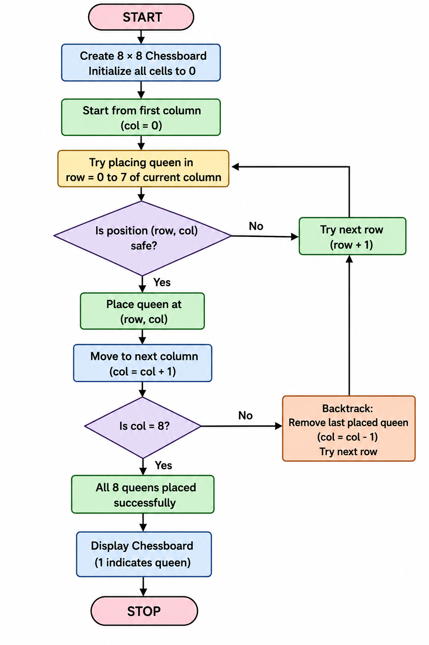

Code:
N = 8
board = [[0] * N for i in range(N)]
def safe(r, c):
for i in range(c):
if board[r][i] == 1:
return False
i = r
j = c
while i >= 0 and j >= 0:
if board[i][j] == 1:
return False
i -= 1
j -= 1
i = r
j = c
while i < N and j >= 0:
if board[i][j] == 1:
return False
i += 1
j -= 1
return True
def queen(c):
if c == N:
return True
for r in range(N):
if safe(r, c):
board[r][c] = 1
if queen(c + 1):
return True
board[r][c] = 0
return False
queen(0)
print("Solution:\n")
for i in board:
print(i)

+Output
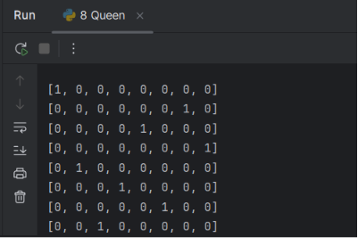
Result
The 8-Queen Puzzle was successfully solved using the Backtracking algorithm. The program placed all 8 queens on the chessboard without any two queens attacking each other.

